Report Title

Documentation of

Library Management System

(Keywordio)

Prasad Adhav | Assessment | 10/06/2022

**Database**: My-SQL

**Editor**: VS Code

**Front-End** **Technology**: Bootstrap 5.2

*This is the brief documentation of the app called “****Library Management System****”.*

## Views.py

1. home:

def home(request):

  return render(request,'home.html')

1. admin_signup:

def admin_signup(request):

    if request.method=="POST":

        fm=UserCreationForm(request.POST)

        # print(fm)

        if fm.is_valid():

            uname=fm.cleaned_data['username']

            upass=fm.cleaned_data['password1']

            #print(uname)

            #print(upass)

            u=User.objects.create_user(username=uname,password=upass,

is_superuser=True,is_staff=True)

            u.save()

            return HttpResponseRedirect('/user_login/')

    else:

        fm=UserCreationForm()

    return render(request,'admin_signup.html',{'form':fm})

# VIEW FOR ADMIN SIGNUP END

1. sign_up:

def signup(request):

    if request.method=="POST":

        fm=UserCreationForm(request.POST)

        # print(fm)

        if fm.is_valid():

            uname=fm.cleaned_data['username']

            upass=fm.cleaned_data['password1']

            #print(uname)

            #print(upass)

            u=User.objects.create_user(username=uname,password=upass,

is_staff=True)

            u.save()

            return HttpResponseRedirect('/user_login/')

    else:

        fm=UserCreationForm()

    return render(request,'signup.html',{'form':fm})

1. user_login:

# VIEW FOR USER LOGIN  START

def user_login(request):

    if request.method=="POST":

        fm=AuthenticationForm(request=request,data=request.POST)

        if fm.is_valid():

            uname=fm.cleaned_data['username']

            upass=fm.cleaned_data['password']

            u=authenticate(username=uname,password=upass)

            if u is not None:

                print("valid user")

              login(request,u)

                return HttpResponseRedirect('/dashboard/')

    else:

        fm=AuthenticationForm()

    return render(request,'user_login.html',{'form':fm})

1. user_logout:

# VIEW FOR USER LOGOUT START

def user_logout(request):

    logout(request)

    return HttpResponseRedirect('/')

    #return render(request,'user_logout.html')

# VIEW FOR USER LOGOUT END

1. dashboard:

def dashboard(request):

    #coolecting authenticated user is from the session

    c=request.user

    cuid=c.id

    # print(cuid)

    u=User.objects.get(id=cuid)

    print(u.is_superuser)

    b=Book.objects.all()

    content={}

    content['data'] = b

    content['is_superuser']=u.is_superuser

    return render(request,'dashboard.html',content)

1. add_book:

# VIEW FOR ADDING BOOK START

def add_book(request):

    if request.method=="POST":

        bname=request.POST['bname']

        bauthor=request.POST['bauthor']

        # print(bname)

        # print(bauthor)

        b=Book.objects.create(name=bname,author=bauthor)

        b.save()

        return HttpResponseRedirect('/dashboard/')

    else:

        return render(request,'add_book.html')

1. delete_book:

# VIEW FOR DELETE BOOK START

def delete_book(request,rid):

    b=Book.objects.filter(id=rid)

    b.delete()

return HttpResponseRedirect('/dashboard/')

1. edit_book:

# VIEW FOR Edit BOOK START

def edit_book(request,rid):

    if request.method=="POST":

        uname=request.POST['bname']

        uauthor=request.POST['bauthor']

        b=Book.objects.filter(id=rid)

        b.update(name=uname,author=uauthor)

        return HttpResponseRedirect('/dashboard/')

    else:

        b=Book.objects.filter(id=rid)

        content={}

        content['data']=b

        return render(request,'edit_book.html',content)

urls.py

from django.contrib import admin

from django.urls import path

from libapp import views

urlpatterns = [

    path('admin/', admin.site.urls),

    path('',views.home,name='home'),

    path('admin_signup/',views.admin_signup,name='admin_signup'),

    path('signup/',views.signup,name='signup'),

    path('user_login/',views.user_login,name='user_login'),

    path('user_logout/',views.user_logout,name='user_logout'),

    path('dashboard/',views.dashboard,name='dashboard'),

    path('add_book/',views.add_book,name='add_book'),

    path('delete/<rid>',views.delete_book,name='delete_book'),

    path('edit/<rid>',views.edit_book,name='edit_book'),

]

models.py

from django.db import models

# Create your models here.

class Book(models.Model):

    name=models.CharField(max_length=50)

    author=models.CharField(max_length=50)

settings.py

DataBase(MySQL)

DATABASES = {

    'default': {

        'ENGINE': 'django.db.backends.mysql',

        'NAME': 'mydatabase',

        'USER':'root',

        'HOST':'localhost',

        'PASSWORD':''

               }

           }

Web View

Home(before login)

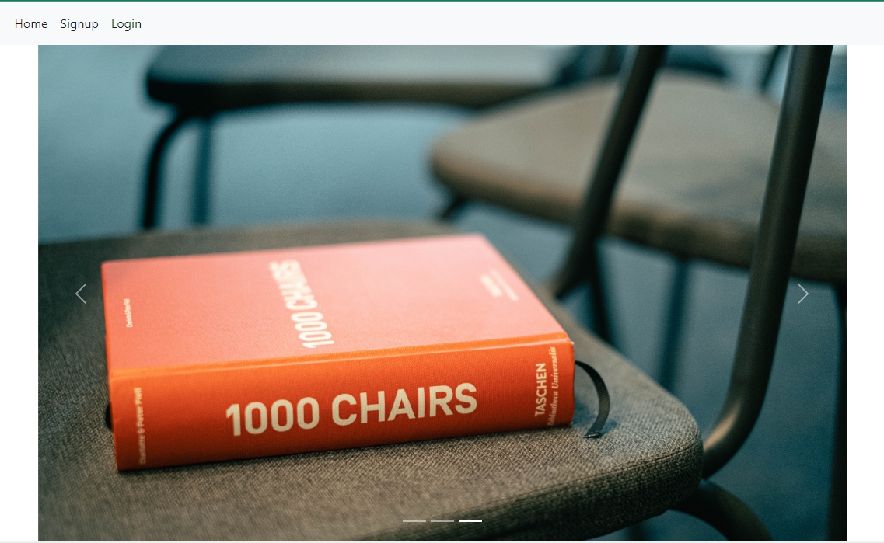

Home(after login)



Dashboard

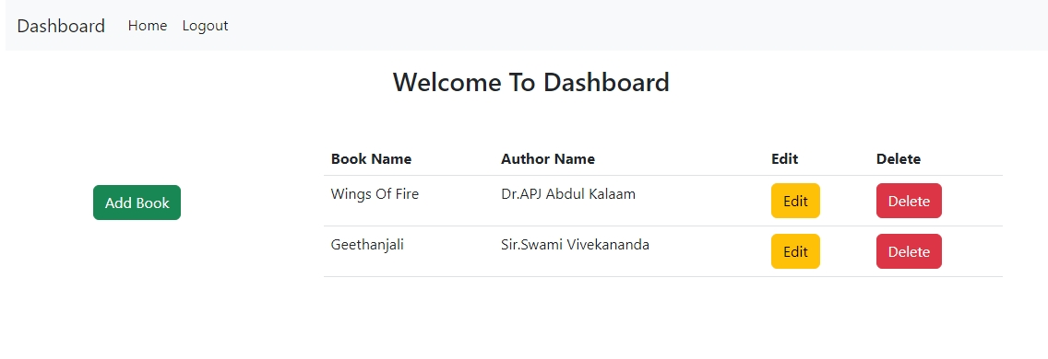

Add Book

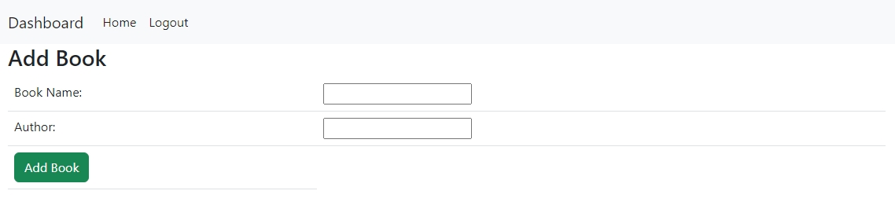

Update Book

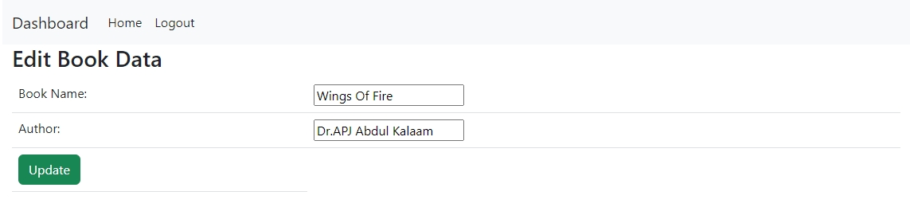

Admin_signup/student_signup

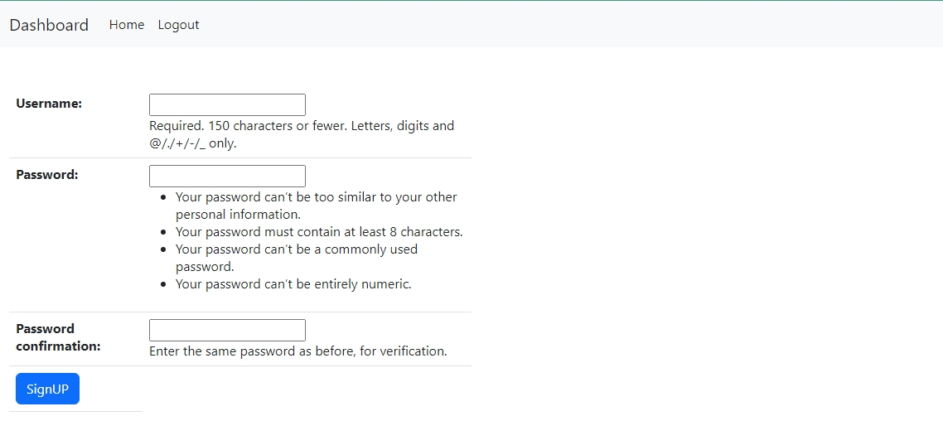

Login

